LEAFLET

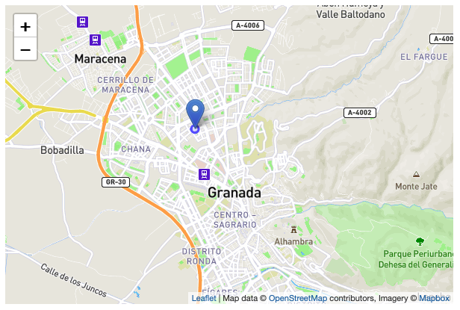

Preparing your page:

First you need to include the style sheet in the head section of the html, and the JavaScript file of leaflet after.

In the html you need to add a div in wich the map will be placed, it needs to have a id to identify the div

With all that steps done, we can start to set up the map. First, we need to create a map variable with the geographical coordinates and a zoom level

Next, we’ll add a tile layer to add to our map, in this case it’s a Mapbox Streets tile layer. It’s important that all the code is called after the div and leaflet JavaScript

I also added a popup when a user make a click on the map and it shows the latitude and longitude of the selected point. I added a pointer of a leaf too, the icon can be replaced with any icon.